Comparison of compiler and interpreter
compiler and interpreter are tool to translate high level code into machine readable instructions but the fundamental is different.

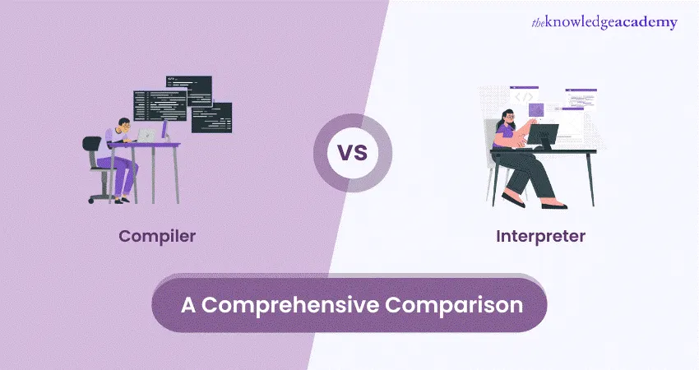
1-Compiler
Translates the entire source code into machine code before executing all file executable.
-faster execution
- reports errors after full compilation
-speed critical applications
-distributing closed source software
2-Interpreter
translates and executes code line by line at runtime
-slower
- stops at the first error
-cross platform compatibility
-quick iterations and scripting

